**Cost-effectiveness of budesonide-formoterol versus inhaled epinephrine in US adults with mild asthma**

Joseph Khoa Ho1, PharmD; Marcus Shaker2, MD MS; Matthew Greenhawt3, MD, MBA, MSc; Mohsen Sadatsafavi1, MD PhD; Elissa M Abrams4, MD MPH; John Oppenheimer5, MD; Giselle S. Mosnaim6, MD MS; Tae Yoon Lee1, MSc; Kate M. Johnson1,7, PhD

**Affiliations:**

1. Respiratory Evaluation Sciences Program, Faculty of Pharmaceutical Sciences, University of British Columbia, Vancouver, British Columbia, Canada
2. Section of Allergy and Immunology, Dartmouth-Hitchcock Medical Center, Lebanon, New Hampshire
3. Section of Allergy and Clinical Immunology, Children's Hospital Colorado, University of Colorado School of Medicine, Aurora, Colorado
4. Department of Pediatrics, Section of Allergy and Clinical Immunology, University of Manitoba, Winnipeg, Manitoba, Canada
5. UMDNJ Rutgers University School of Medicine, Newark, New Jersey
6. Division of Allergy, Asthma, and Immunology, Department of Medicine, NorthShore University Health System, Evanston, IL
7. Division of Respiratory Medicine, Department of Medicine, University of British Columbia, Vancouver, British Columbia, Canada

**Corresponding Author:**

Kate Johnson, PhD

Assistant Professor

Faculty of Pharmaceutical Sciences

University of British Columbia

2405 Wesbrook Mall, Vancouver BC, V6T 1Z3

[Kate.johnson@ubc.ca](mailto:Kate.johnson@ubc.ca)

604-861-2030

**Funding:** This study received no external funding.

**Contributions:** M. Shaker and MG formulated the research question and conceptualized the study. JKH and KJ developed the study design and analytic plan. M. Sadatsafavi and TYL provided feedback on the analytic plan. JKH performed the analysis. JKH, KJ, and M. Shaker wrote the first draft of the manuscript. M. Shaker, MG, EA, JO, and GM provided clinical context to the results of the analysis. All authors commented on and revised previous versions of the manuscripts and approved the final manuscript. KJ is the guarantor of the study.

**Text:** 3304

**Conflict of Interest:**

* **Joseph Khoa Ho**: has no conflicts to disclose.
* **Marcus Shaker:** has participated in research that has received funding by DBV; is a member of the Joint Task Force on Practice Parameters; serves as an associated editor for Annals of Allergy, Asthma, and Immunology; is an editorial board member for the Journal of Allergy and Clinical Immunology In Practice.
* **Matthew Greenhawt:** is a consultant for Aquestive; is a member of physician/medical advisory boards for DBV Technologies, Sanofi/Regeneron, Nutricia, Novartis, Aquestive, Allergy Therapeutics, AstraZeneca, ALK-Abello, and Prota; is an unpaid member of the scientific advisory council for the National Peanut Board and medical advisory board of the International Food Protein Induced Enterocolitis Syndrome Association; is a member of the Brighton Collaboration Criteria Vaccine Anaphylaxis 2.0 working group; is the senior associate editor for the Annals of Allergy, Asthma, and Immunology, and is member of the Joint Taskforce on Allergy Practice Parameters. He has received honorarium for lectures from ImSci, RMSI, MedLearningGroup, and multiple state/local allergy societies.
* **Mohsen Sadatsafavi:** has received honoraria from GlaxoSmithKline and AstraZeneca for unrelated activities. He has also received funding into his research account from AstraZeneca and GlaxoSmithKline for unrelated projects.
* **Elissa Abrams:** is an employee of Public Health Agency of Canada (PHAC); views expressed are her own and not those of PHAC.
* **John Oppenheimer**: is a consultant for Amgen, Aimmune, Aquestive, GSK, Sanofi; member of the Adjudication or Data Safety Monitoring Board for AstraZeneca, Amgen, Abbvie, Novartis, GlaxoSmithKline; is the Executive Editor for the Annals of Allergy Asthma and Immunology; and a reviewer for UpToDate.
* **Giselle Mosnaim:** receives current research grant support from GlaxoSmithKline, Novartis, Sanofi/Regeneron and has received past research grant support from AstraZeneca, ALK-Abello, Teva and Genentech.
* **Tae Yoon Lee:** has no conflicts to disclose.
* **Kate Johnson:** has no conflicts to disclose.

**ABSTRACT**

**Background:** Inhaled epinephrine is the only available over-the-counter (OTC) treatment for the management of mild asthma in the United States (US). However, inhaled epinephrine without use of an inhaled corticosteroid (ICS) may increase the risk of asthma death.

**Objective:** To compare the cost-effectiveness of OTC as-needed budesonide-formoterol to inhaled epinephrine.

**Methods:** We developed a probabilistic Markov model to compare OTC as-needed budesonide-formoterol inhaler use vs. inhaled epinephrine use in adults with mild asthma from a US societal perspective, over a lifetime horizon, with a 3% annual discount rate (2022 US dollars). Inputs were derived from the SYGMA trials, published literature, and commercial costs. Outcomes were quality-adjusted life-years (QALY), costs, incremental net monetary benefit (INMB), severe asthma exacerbations, well-controlled asthma days, and asthma-related deaths. Microsimulation was used to evaluate underinsured Americans living with mild asthma (n=5,250,000).

**Results:** As-needed budesonide-formoterol dominated inhaled epinephrine, with QALY gains at lower cost (INMB, $15,541 at a willingness-to-pay of $100,000 per QALY), and the no OTC inhaler option (INMB, $1,023). Adults using as-needed budesonide-formoterol had 145 more well-controlled asthma days, 2.79 fewer severe exacerbations, and an absolute risk reduction of 0.23% for asthma-related death compared to inhaled epinephrine over a patient lifetime. As-needed budesonide-formoterol remained dominant in all sensitivity and scenario analyses, with a 100% probability of being cost-effective compared to inhaled epinephrine in probabilistic sensitivity analysis.

**Conclusions:** If made available, OTC as-needed budesonide-formoterol for the management of mild asthma in underinsured adults without HCP management would improve asthma outcomes and prevent fatalities while being cost-saving.

**Abstract Word Count:** 250

**Key Messages**

* OTC as-needed budesonide-formoterol inhaler for the management of mild asthma in underinsured adults was both more effective and less costly compared to using inhaled epinephrine.
* The cost savings associated with OTC budesonide-formoterol suggest that its availability as an OTC treatment option could improve asthma outcomes while being cost-saving.

**Capsule Summary**

This study demonstrates that making over-the-counter (OTC) as-needed budesonide-formoterol available for underinsured adults with mild asthma can lead to improved outcomes, cost savings, and a reduced risk of asthma-related deaths.

**Key Words:** Asthma, cost-effectiveness analysis, budesonide-formoterol, epinephrine, over the counter.

**ABBREVIATIONS**

**BLS:** Bureau of Labor Statistics

**CDC:** Centers for Disease Control and Prevention

**CHEERS:** Consolidated Health Economic Reporting Standards

**DALY:** Disability-adjusted life years

**ED:** Emergency department

**FDA:** Food and Drug Administration

**EQ-5D-5L:** EuroQoL-5 Dimension-5 Level

**GINA:** Global Initiative for Asthma

**HCP:** Healthcare professional

**ICS:** Inhaled corticosteroid

**LABA:** Long-acting beta-agonist

**OTC:** Over-the-counter

**SABA:** Short-acting beta-agonist

**SCS:** Systemic corticosteroid

**QALY:** Quality-adjusted life years

**US:** United States

**YLD**: Years lived with disability

**INTRODUCTION**

Asthma is an obstructive, inflammatory disease of the airways with fluctuating symptoms of shortness of breath, wheezing, chest tightness, and excessive coughing.1 Globally, asthma was associated with 10,623 (95%CI 7,057-15,056) thousand years lived with disability (YLD) and 22,800 (95%CI 18,100-28,300) thousand disability-adjusted life years (DALY) in 2017 alone.2,3 It is a highly common chronic condition in the United States (US), affecting the lives of approximately 25 million Americans, with an estimated 11 people dying each day and disproportionate effects on females and Black adults.4–8 Uncontrolled asthma also has a substantial economic burden. Over the next 20 years, the costs of medical care and lost productivity due to uncontrolled asthma in the US is projected to be $963 billion, with 15.46 million quality-adjusted life years (QALYs) lost.9,10 The high proportion of Americans who are uninsured (8%) or underinsured (28%) contributes to suboptimal management, particularly in mild asthma, which constitutes 67-70% of all asthma cases and leads to considerable strain on society.11–16 Underinsurance is defined as people whose health insurance provides inadequate coverage for healthcare expenses because their out-of-pocket costs are equal to 10% or more of their household income; alternatively, it can also be defined as having a deductible that constitutes 5% or more of their household income.17 Patients with mild asthma are also at risk of progressing to more severe and persistent asthma, and of asthma-related fatality.18 Strategies to improve asthma control in the estimated 5.25 million underinsured Americans with mild asthma could significantly reduce the burden of asthma in this vulnerable population.19

In 2018, an inhaled epinephrine product (Primatene Mist) was re-approved in the US as the only over-the-counter (OTC) inhaler for the management of asthma, making it an inexpensive, accessible option for underinsured patients with limited access to physician care.19 Inhaled epinephrine was previously available OTC from 1967 to 2011 but was taken off the market due to ozone-depleting chlorofluorocarbons contained in inhalers. Several medical organizations opposed its reapproval due to concerns of poor effectiveness compared to other short-acting beta-agonists (SABA), increased risk of cardiac toxicity from lack of pulmonary selectivity, and potential for increased asthma fatality with SABA overuse.19–21 These concerns were not addressed prior to Primatene Mist being re-approved. While it is unlikely that the Food and Drug Administration (FDA) will remove OTC epinephrine inhalers from the market, it would be beneficial to evaluate switching from prescription-to-OTC for inhalers that are safer and more effective.19

The Global Initiative for Asthma (GINA) clinical guidelines recommend maintenance inhaled corticosteroids (ICS) with SABA reliever therapy in patients with mild asthma.1 However, in a recent amendment, these guidelines now also advocate for symptom-driven as-needed low-dose ICS in combination with a long-acting beta-agonist (LABA) in patients over 12 years with mild asthma.1 The shift to ICS-LABA as-needed reliever therapy was supported by evidence from, among others, the landmark SYGMA trials, showing that as-needed budesonide-formoterol was non-inferior to ICS maintenance with as-needed SABA reliever (budesonide twice daily plus as-needed terbutaline) for reducing the annual rate of severe exacerbations.22–25

The GINA recommendations for as-needed budesonide-formoterol have generated considerable interest in its potential to be made available as an OTC product, which could be a safer and more effective alternative to inhaled epinephrine.19,26,27 The objective of this study is to compare the cost-effectiveness of as-needed budesonide-formoterol to as-needed inhaled epinephrine as OTC products and a no OTC inhaler option from a US societal perspective in underinsured adults with mild asthma.

**METHODS**

The study is reported in accordance with the Consolidated Health Economic Reporting Standards (CHEERS) statement (checklist found in **e-Table 1**).28 The target population was US adults ≥ 19 years of age with mild, persistent asthma that is not managed by a healthcare professional (HCP). The primary outcomes were incremental costs and QALYs between comparator scenarios consisting of OTC as-needed management with inhaled epinephrine (the *status quo*), OTC management with as-needed budesonide-formoterol, or no OTC inhaler option. Incremental cost-effectiveness ratio (ICER) and incremental net monetary benefit (INMB) were assessed at a willingness-to-pay (WTP) of $100,000 per QALY gained. We adopted a US societal perspective with a lifetime horizon of up to 81 years in the base-case analysis. A discount rate of 3% per annum for both costs and QALYs was applied based on recommendations from the US Panel on Cost-Effectiveness in Health and Medicine.29 All costs are reported in 2022 US dollars ($). This study does not use human subjects and is exempt from institutional review board approval.

**Model Structure**

We developed a probabilistic Markov cohort model with weekly cycles to assess costs and QALYs in 5 health states (**Figure 1**): (1) no HCP management; (2) HCP management; (3) severe exacerbation; (4) recovery from severe exacerbation; and (5) death. Patients entered the model in the no HCP management state, where asthma was managed with the OTC medication specific to each comparator scenario. In the base-case, patients only entered HCP management following a severe exacerbation, where they received maintenance low-dose ICS plus as-needed SABA. Patients in the HCP and no HCP management states could have well-controlled or not well-controlled asthma. The risk of transitioning into the severe exacerbation state was specific to the treatment comparator and asthma control. A severe exacerbation was defined as an acute worsening of asthma requiring at least 3 days of systemic corticosteroid (SCS) use, an emergency department visit requiring SCS treatment (ED visit + SCS), or hospitalization. Patients remained in the severe exacerbation state for one week before transitioning into the exacerbation recovery state where they remained with not well-controlled asthma for an exponentially distributed time with an average of 4 weeks. All patients leaving the exacerbation recovery state entered HCP management, but patients could subsequently be non-adherent and return to no HCP management. Mortality occurred from two sources: asthma-related mortality following a severe exacerbation, and all-cause mortality, which could occur from any state. The model used weekly cycles to reflect the duration of severe asthma exacerbations reported in SYGMA 2.23 The model was implemented in R version 4.2.1 (R Foundation for Statistical Computing, Vienna, Austria) and is publicly available on a Github repository <https://github.com/resplab/ASTHMA-CEA-2022>.

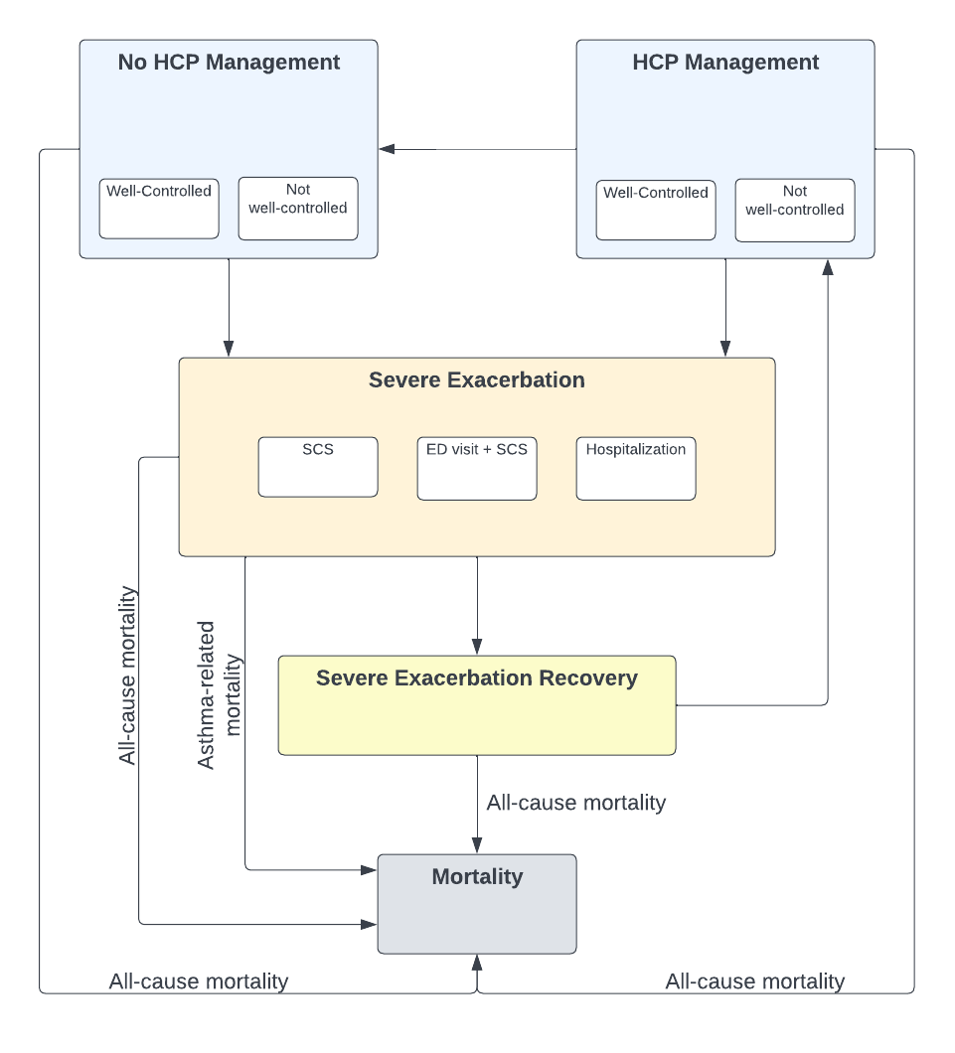

**Figure 1.** Model Schematic.

ED: emergency department; HCP: healthcare professional; SCS: systemic corticosteroid.

**Probabilities and Events**

Transition probabilities between the non-exacerbation and exacerbation states were based on annual severe exacerbation rates from the SYGMA trials (**Table 1**).22,23 In the no HCP management state, we used the annual rate of severe exacerbation from the SYGMA 1 as-needed terbutaline arm (0.20) for inhaled epinephrine and no OTC inhaler comparators. The assumption that the exacerbation rate for inhaled epinephrine would be similar to terbutaline was based on expert opinion and the lack of high-quality studies evaluating inhaled epinephrine. For the budesonide-formoterol comparator, we used the annual severe exacerbation rate in the respective arm of SYGMA 2 (0.11). The annual rate of severe exacerbations in the HCP management state was based on the SYGMA 1 budesonide maintenance plus as-needed terbutaline arm (0.09). We converted annual rates to weekly probabilities assuming a constant treatment effect. The proportion of severe exacerbations of each severity (SCS > 3 days, ED visit + SCS, and hospitalization) was determined from the same treatment arms of SYGMA 1 and 2 **(Table 1)**. Following a severe exacerbation and recovery, all patients entered HCP management regardless of insurance status. They returned to no HCP management with an annual probability of 0.21, which was based on the rate of non-adherence in the budesonide maintenance arm of SYGMA 1 and encompasses maintenance therapy discontinuation from all causes, including failure to obtain health insurance.

Asthma control was measured in SYGMA 1 based on as-needed inhaler use, symptom scores, nighttime awakenings, morning peak expiratory flow, and additional use of inhaled or systemic corticosteroids.22 We applied the proportion of weeks with well-controlled asthma in the terbutaline and budesonide-formoterol arms of SYGMA 1 to model the proportion of patients with well-controlled asthma in the inhaled epinephrine/no OTC inhaler and budesonide-formoterol comparator strategies, respectively, and asthma control in the budesonide maintenance arm of SYGMA 1 for HCP management. We applied a rate ratio of 1.2 for exacerbations among patients with asthma that was not well-controlled, compared to well-controlled. This value was derived as the weighted average of severe exacerbation rates in partially controlled and uncontrolled asthma relative to controlled asthma from a large study of US commercial health claims.30

Mortality due to severe exacerbations was based on patient age and exacerbation severity (shown in **e-Table 2**). For the annual risk of death from severe exacerbations requiring SCS or an ED visit we used (separate) annual rates from Watson et al.31 and the National Review of Asthma Deaths 2017, converted to a weekly probability.32 For exacerbations requiring hospitalization, we used estimates from Watson et al.31 and Roberts et al.33 We modeled an additional risk of death due to SABA use alone associated with inhaled epinephrine, using an odds ratio of 2.6 per canister from Spitzer et al.,20 after converting probabilities to odds. Given the limited evidence on inhaled epinephrine and asthma fatality, we assumed this class effect. We regard this assumption as conservative given the additional cardiac toxicity and adverse effects of inhaled epinephrine compared to other SABAs. Age- and sex-specific background mortality was determined from 2019 US life tables.34 The total risk of mortality in each model cycle was the sum of asthma-related mortality and the background risk of mortality.

**Table 1:** Summary of Model Parameters

|  |  |  |  |  |
| --- | --- | --- | --- | --- |
|  | Base-case | DSA (Lower/Upper) | PSA distribution | Source |
| Baseline age | 19 |  |  |  |
| Relative rate of severe exacerbations for not-well controlled asthma a | 1.20 |  | Log-normal (0.18, 0.09) | Pollack et al. 2022 30 |
| Odds ratio for asthma-related mortality from SABA overuse | 2.60 |  | Log-normal (0.96, 0.20) | Spitzer et al. 1992 20 |
| Annual probability of adherence to HCP management | 0.79 | 0.63/0.95 | Beta (a=3355, b=897.3) | SYGMA 1 22 |
| Annual probability of entering HCP management from no HCP state | Not included | 0.00/0.20 |  |  |
| Discount rate (% per annum) | 3.0 |  |  |  |
| Cycle length | 1 week |  |  |  |
| Annual severe exacerbation rate | | | | |
| No OTC inhaler | 0.20 | 0.16/0.24 | Gamma (a=100, b=0.002) | SYGMA 1 22 |
| As-needed inhaled epinephrine | 0.20 | 0.16/0.24 | Gamma (a=100, b=0.002) | SYGMA 1 22 |
| As-needed budesonide-formoterol | 0.11 | 0.09/0.13 | Gamma (a=116, b=0.001) | SYGMA 2 23 |
| HCP management state (maintenance ICS + as-needed SABA) | 0.09 | 0.07/0.11 | Gamma (a=138, b=0.001) | SYGMA 1 22 |
| Distribution of patients by severe exacerbation states |  |  | Dirichlet (% across states must sum to 100%) |  |
| *No OTC inhaler* |  |  |  | SYGMA 1 22 |
| SCS | 77.6 |  |  |  |
| ED+SCS | 13.0 |  |  |  |
| Hospitalization | 9.4 |  |  |  |
| *As-needed inhaled epinephrine* |  |  |  | SYGMA 1 22 |
| SCS | 77.6 |  |  |  |
| ED+SCS | 13.0 |  |  |  |
| Hospitalization | 9.4 |  |  |  |
| *As-needed budesonide-formoterol* |  |  |  | SYGMA 2 23 |
| SCS | 82.0 |  |  |  |
| ED+SCS | 10.2 |  |  |  |
| Hospitalization | 7.8 |  |  |  |
| *HCP management state (maintenance ICS + as-needed SABA)* |  |  |  | SYGMA 1 22 |
| SCS | 82.4 |  |  |  |
| ED+SCS | 9.8 |  |  |  |
| Hospitalization | 7.8 |  |  |  |
| Weekly probability of exiting exacerbation recovery state | 0.221 |  |  | Assumption |
| Proportion with well-controlled asthma |  |  |  | SYGMA 1 22 |
| No OTC inhaler | 0.31 |  | Beta (a=6,889, b=15,263) |  |
| As-needed inhaled epinephrine | 0.31 |  | Beta (a=6,889, b=15,263) |  |
| As-needed budesonide-formoterol | 0.34 |  | Beta (a=6,560, b=12,509) |  |
| HCP management state (maintenance ICS + as-needed SABA) | 0.44 |  | Beta (a=5,560, b=6,962) |  |
| Medication inhalations per day |  |  |  |  |
| As-needed inhaled epinephrine | 0.52 | 0.42/0.62 | Gamma (a=100, b=0.005) | SYGMA 2 23 |
| As-needed budesonide-formoterol | 0.52 | 0.42/0.62 | Gamma (a=100, b=0.005) | SYGMA 2 23 |
| Maintenance ICS + as-needed SABA |  |  |  |  |
| ICS | 2.00 | 1.6/2.4 | Gamma (a=100, b=0.02) | SYGMA 2 23 |
| SABA | 0.49 | 0.39/0.59 | Gamma (a=100, b=0.005) | SYGMA 2 23 |
| Direct Costs |  |  |  |  |
| HCP management (week) | 52.95 | 42.36/63.54 | Gamma (a=26.8, b=102.9) | Yaghoubi et al. 2020 35 |
| Asthma not well-controlled (week) | 15.05 | 12.04/18.06 | Gamma (a=100, b=0.15) | Yaghoubi et al. 2020 35 |
| Severe exacerbation unit costs (per event) |  |  |  | Campbell et al. 2010 36 |
| SCS | 162.91 | 130.33/195.50 | Gamma (a=100, b= 1.62) |  |
| ED+SCS | 743.97 | 595.17/892.76 | Gamma (a=100, b= 7.44) |  |
| Hospitalization | 12,397.63 | 9,918.10/14,877.20 | Gamma (a=100, b= 124) |  |
| Drug acquisition costs (per day) b |  |  | Fixed | GoodRx 37 |
| As-needed inhaled  epinephrine | 0.10 |  |  |  |
| As-needed  budesonide-formoterol | 1.35 |  |  |  |
| Maintenance ICS + as-  needed SABA |  |  |  |  |
| ICS | 5.44 |  |  |  |
| SABA | 0.13 |  |  |  |
| Indirect Costs |  |  |  |  |
| HCP management time costs (week) c | 3.03 |  | Normal (320, 32) | Shaker et al. 2020,38 Bureau of Labor Statistics 39 |
| Productivity loss due to asthma not well-controlled (week) d | 131.70 |  | Log-normal (-2.06, 0.11) | Shaker et al. 2020,38 Bureau of Labor Statistics 39 |
| Productivity loss due to severe exacerbation (per event) e |  |  |  | Bureau of Labor Statistics 39 |
| SCS | 296.29 |  | Log-normal (-1.25, 0.09) |  |
| ED+SCS | 592.57 |  | Log-normal (-0.56, 0.09) |  |
| Hospitalization | 1037.00 |  | Log-normal (0, 0.09) |  |
| Utility |  |  |  |  |
| Utility of non-exacerbation | 0.87 | 0.70/1.00 | Beta (a=12.43, b=1.91) | SYGMA 2 23 |
| Disutility of not well-controlled asthma | -0.07 | -0.06/-0.08 | Log-normal (-2.66, 0.13) | Yaghoubi et al. 2019 9 |
| Disutility of severe exacerbation |  |  |  |  |
| SCS | -0.10 | -0.08/-0.12 | Beta (a=89.9, b=809.1) | Lloyd et al. 2007,40 Sadatsafavi et al. 2021 41 |
| ED+SCS | -0.15 | -0.12/-0.18 | Beta (a=84.9, b=480.8) | Lloyd et al. 2007,40 Sadatsafavi et al. 2021 41 |
| Hospitalization | -0.20 | -0.16/-0.24 | Beta (a=79.8, b=319.2) | Lloyd et al. 2007,40 Sadatsafavi et al. 2021 41 |

ED: emergency department; HCP: healthcare professional; ICS: inhaled corticosteroid; OTC: over-the-counter; SABA: short-acting beta-agonist; SCS: systemic corticosteroid; US: United States. All costs are adjusted to 2022 USD using the US consumer price index.

a Calculated as a weighted average of partially controlled and uncontrolled asthma compared to controlled asthma.

b Drug acquisition costs were assumed to be fixed.

c Assuming 320 total minutes for 4 PCP visits per year, comprised of 20 minutes travel time each way and 40 minutes wait time based on Shaker et al. 2020,38 and median weekly wages from BLS ($1,037) in 2022.39 The PSA varied the total time per week.

d The PSA varied the proportion of the week affected by productivity loss from asthma not well-controlled multiplied by weekly median wage from BLS.39

e Assuming no patient works for 2 days in the severe exacerbation with SCS use, 4 days for severe exacerbation with ED visit, and 7 days for severe exacerbation leading to hospitalization. The PSA varied the number of days of lost work multiplied by weekly median wage from BLS.

**Resource Use and Costs**

We derived drug acquisition costs from the mean discounted brand retail prices using GoodRx (search conducted on June 2022),37 an online drug pricing index that reports average OTC and prescription drug costs for major retail pharmacies in the US.37 Daily inhalations for the OTC comparators were taken from SYGMA 2 (**Table 2**).23 We used the medical costs of HCP management for well-controlled asthma from a meta-analysis of asthma-related healthcare resource use in the US, with an additional cost applied for each day asthma was not well-controlled.35 The indirect costs of productivity loss due to presenteeism and absenteeism from asthma that is not well-controlled were derived from the same study. The medical costs of severe exacerbations were determined from the literature based on analysis of unit costs for asthma-related utilization in US commercial claims data.36 Productivity loss due to severe exacerbations was based on average weekly wage estimates from the Bureau of Labor Statistics (BLS), assuming 2 days of lost wages for severe exacerbations requiring SCS use, 4 days for exacerbations requiring ED visits + SCS use, and 7 days for asthma-related hospitalizations.39 Travel and wait times associated with primary care physician visits were combined with BLS wage estimates to determine time use costs for the HCP management state.38

**Table 2:** Drug Acquisition Costs

|  |  |  |  |  |  |
| --- | --- | --- | --- | --- | --- |
| Therapy | Inhaler | Cost per inhaler a | Inhalations per inhaler | Inhalations per day | Cost per day ($) |
| Epinephrine OTC | Primatene Mist 0.125 μg | $29.78 | 160 doses | 0.52 b | 0.10 |
| Budesonide-formoterol OTC | Symbicort 160 μg/4.5 μg | $311.49 | 120 doses | 0.52 b | 1.35 |
| Maintenance  ICS + SABA | Salbutamol 90 μg (Ventolin) | $54.42 | 200 doses | 0.49 c | 0.13 |
| Fluticasone 110 μg (Flovent) | $326.28 | 120 doses | 2.00 d | 5.44 |

ICS: inhaled corticosteroid; OTC: over-the-counter; SABA: short-acting beta-agonist.

a Average discounted brand retail price posted on GoodRx.com on June 2022 37 (2022 USD)

b Mean number of inhalations per day based on as-needed budesonide-formoterol arm in SYGMA 2 23

c Mean number of inhalations per day of terbutaline based on maintenance budesonide + terbutaline arm in SYGMA 2 23

d Prescribed number of inhalations per day based on maintenance budesonide + terbutaline arm in SYGMA 2 23

**Health State Utilities**

We used utility data collected in SYGMA 2 with the EuroQoL-5 Dimension-5 Level (EQ-5D-5L) for the non-exacerbation health states (0.867).23 The disutility of not well-controlled asthma (-0.07) was based on the 2011 US National Health and Wellness Survey.42 The disutility of severe exacerbations requiring SCS use (-0.10) and hospitalization (-0.20) were derived from Lloyd et al.,40 as have been used in similar cost-effectiveness analyses.41,43 We applied a midpoint value (-0.15) for the disutility of severe exacerbation requiring an ED visit + SCS use.

**Microsimulation**

We conducted a microsimulation with 100,000 patients under base-case assumptions to evaluate comparator strategies in the population of underinsured Americans living with mild asthma (n=5,250,000),4–7 assuming 28% of the 25 million Americans with asthma are underinsured,12 and that 75% of asthma cases are mild.14 We calculated stochastic variance for the per-patient base-case results, total costs, QALYs, asthma control days, severe exacerbations, and asthma fatalities by multiplying mean per-patient outcomes by the total population size.

**Sensitivity Analyses**

We performed one-way deterministic sensitivity analyses to evaluate the impact of varying the number of inhalations per day for as-needed inhalers, annual severe exacerbation rates, unit costs, utility values, annual probability of non-adherence, and the probability of directly entering HCP management from no HCP management without having a severe exacerbation by ± 20% of their base case values. We performed a probabilistic sensitivity analysis (PSA) using Monte Carlo simulations with 1000 iterations. Probability distributions for each model parameter were constructed using uncertainty estimates reported in the original studies (e.g., standard errors, 95% confidence intervals) (**Table 1**). We assumed a coefficient of variation of 10% when this information was not available. Finally, we assessed the robustness of our results under the following scenarios with 1000 PSA iterations: (1) 0% discount rate for both costs and benefits; (2) 6.0% discount rate for both costs and benefits; (3) time horizon of 10 years; (4) time horizon of 30 years; and (5) a public payer perspective.

**RESULTS**

**Base-case Analysis**

Results from the base-case analysis are presented in **Table 3**. Budesonide-formoterol dominated the no OTC inhaler comparator by being more effective and less costly, and in turn dominated inhaled epinephrine, with incremental cost-savings of $13,371 and QALY gains of 0.022 per-patient, making it the preferred strategy (INMB of $15,541). The no OTC inhaler option also dominated inhaled epinephrine, with cost-savings of $497 and QALY gains of 0.006 per-patient (INMB of $1,023). The total discounted costs of treatment over a lifetime were $183,927 for budesonide-formoterol, $196,801 with no OTC inhaler, and $197,298 for inhaled epinephrine. Total discounted QALYs were 22.469 for budesonide-formoterol, 22.453 with no OTC inhaler, and 22.447 for inhaled epinephrine. Compared to inhaled epinephrine, budesonide-formoterol resulted in 145 more well-controlled asthma days, 2.79 severe exacerbations avoided, and an absolute risk reduction of 0.23% for asthma-related death; no OTC inhaler option resulted in 4 more well-controlled asthma days, <0.01 more severe exacerbations, and an absolute risk reduction of 0.13% for asthma-related death.

**Table 3.** Summary of base-case results. Results are shown per-patient, with standard errors calculated from a microsimulation of 100,000 patients.

|  |  |  |  |  |  |  |  |  |  |
| --- | --- | --- | --- | --- | --- | --- | --- | --- | --- |
|  | Costs ($) | QALYs | Well-controlled days | Severe exacerbations | Asthma-related deaths | Incremental  Costs  ($) | Incremental  QALYs | ICER  ($/QALY) | INMB a  ($) |
| Budesonide-formoterol | 183,927  + 100 | 22.469  + 0.010 | 8,158  + 6.49 | 6.21  + 0.01 | 0.0027  + 0.0002 | -13,371  + 37 | 0.022  + 0.001 | Dominant | 15,541 |
| No OTC Inhaler | 196,801  + 107 | 22.453  + 0.010 | 8,017  + 6.45 | 9.01  + 0.01 | 0.0037  + 0.0002 | -497  + 7 | 0.006  + 0.001 | --- | 1,023 |
| Inhaled Epinephrine | 197,298  + 107 | 22.447  + 0.010 | 8,013  + 6.46 | 9.00  + 0.01 | 0.0050  + 0.0002 | Reference | Reference | Reference | Reference |

ICER: Incremental Cost-Effectiveness Ratio; INMB: incremental net monetary benefit; OTC: over-the-counter; QALY: quality-adjusted life year.

a Incremental net monetary benefit at a willingness-to-pay of $100,000 per QALY gained

**Microsimulation**

Among 5,250,000 underinsured patients with mild asthma in the US, inhaled epinephrine was associated with $1.04 trillion in total costs, 47.25 million severe exacerbations, and 26,040 asthma-related deaths. Budesonide-formoterol was associated with $966 billion in total costs, 32.60 million severe exacerbations, and 14,175 asthma-related deaths, representing an incremental costs savings of $70.29 billion, 14.64 million fewer severe exacerbations, and 11,865 fewer asthma-related deaths compared to inhaled epinephrine. The no OTC inhaler option was associated with $1.03 trillion in total costs, 47.27 million severe exacerbations, and 19,583 asthma-related deaths.

**Deterministic Sensitivity Analyses**

Budesonide-formoterol remained preferred to inhaled epinephrine in all one-way sensitivity analyses (**Figure 2)**. The value of budesonide-formoterol was most influenced by the annual exacerbation rate and probability of obtaining health insurance and entering HCP management directly from no HCP management (without a severe exacerbation). These parameters were also influential for the no OTC inhaler comparator, in addition to the baseline utility of non-exacerbation states, and mean inhalations per day of inhaled epinephrine. INMB results for different WTP thresholds are presented in **e-Figure 1.**

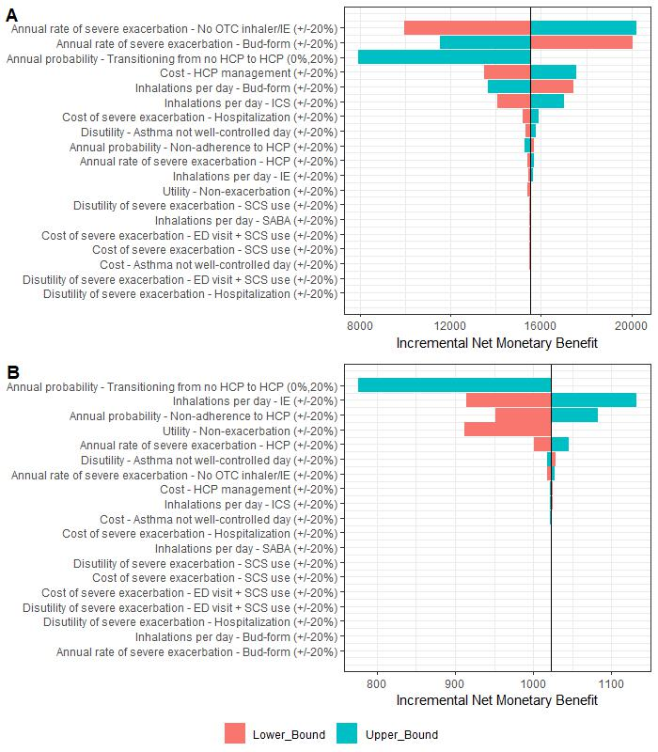

**Figure 2.** One-way sensitivity analysis of the incremental net monetary benefit of a) budesonide-formoterol and b) no OTC inhaler compared to inhaled epinephrine at a willingness-to-pay of $100,000 per QALY. Coloured bars represent the lowest (red) and highest (blue) values of the parameter taken in the sensitivity analysis.

Bud-form: budesonide-formoterol; ED: emergency department; HCP: healthcare professional; ICS: inhaled corticosteroid; IE: inhaled epinephrine, OTC: over-the-counter; SABA: short-acting beta-agonist; SCS: systemic corticosteroid; QALY: quality-adjusted life year.

**Probabilistic Sensitivity Analysis**

The results of the PSA are presented in **Figure 3**. The probability that budesonide-formoterol was cost-effective compared to no OTC inhaler and inhaled epinephrine was 100% at a WTP threshold of $100,000 per QALY gained (cost-effectiveness acceptability curves are shown in **e-Figure 2**). The no OTC inhaler option also had 100% probability of being cost-effective compared to inhaled epinephrine.

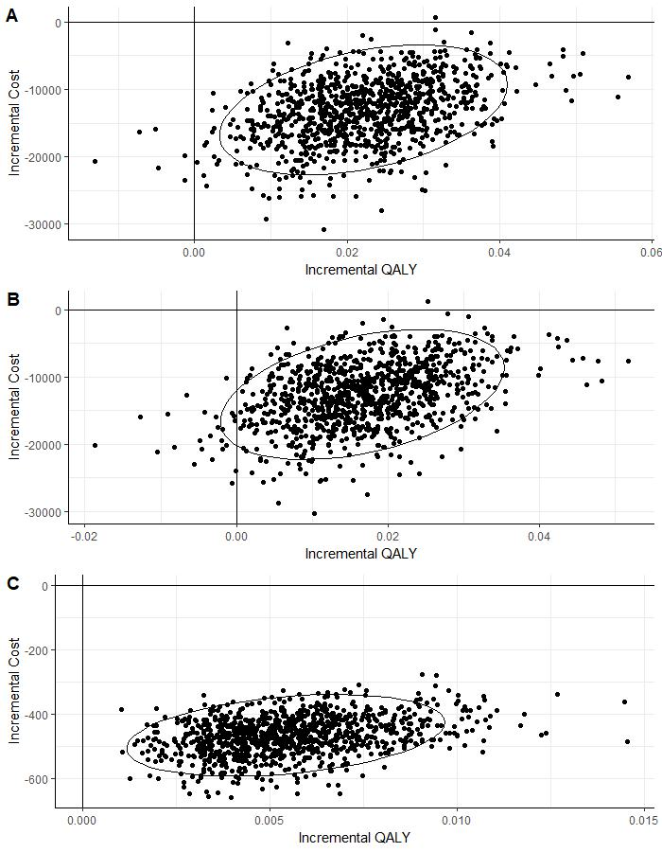

**Figure 3.** Cost-effectiveness plane for a) budesonide-formoterol vs. inhaled epinephrine; b) budesonide-formoterol vs. no OTC inhaler; and c) no OTC inhaler vs. inhaled epinephrine.

QALY: quality-adjusted life year.

Ellipses were constructed assuming a bivariate normal distribution such that they contain 95% of the points.

**Scenario Analyses**

Budesonide-formoterol remained the dominant strategy across all scenarios presented in **Table 4**. In the public payer perspective, the INMB for budesonide-formoterol decreased to $13,061 and the INMB for no OTC inhaler option slightly increased to $1,047 relative to inhaled epinephrine, but budesonide-formoterol remained the preferred strategy.

**Table 4. Scenario Analyses**

|  |  |  |  |  |  |  |
| --- | --- | --- | --- | --- | --- | --- |
|  |  | Total | | Incremental | | |
|  |  | **Costs ($)** | **QALYs** | **Costs**  **($)** | **QALYs** | **INMB a**  **($)** |
| 1: Discount 0% per annum | Budesonide-formoterol | 413,009 | 49.986 | -29,797 | 0.059 | 35,695 |
| No OTC Inhaler | 441,914 | 49.951 | -893 | 0.024 | 3,269 |
| Inhaled Epinephrine | 442,806 | 49.928 | Reference | Reference | Reference |
| 2: Discount 6% per annum | Budesonide-formoterol | 106,382 | 13.123 | -7,486 | 0.012 | 8,725 |
| No OTC Inhaler | 113,570 | 13.112 | -298 | 0.002 | 464 |
| Inhaled Epinephrine | 113,868 | 13.110 | Reference | Reference | Reference |
| 3: Time horizon 10 yrs | Budesonide-formoterol | 56,200 | 7.118 | -3,809 | 0.008 | 4,569 |
| No OTC Inhaler | 59,825 | 7.110 | -184 | 0.000 | 202 |
| Inhaled Epinephrine | 60,009 | 7.110 | Reference | Reference | Reference |
| 4: Time horizon 30 yrs | Budesonide-formoterol | 130,945 | 16.098 | -9,323 | 0.013 | 10,659 |
| No OTC Inhaler | 139,898 | 16.085 | -370 | 0.001 | 474 |
| Inhaled Epinephrine | 140,268 | 16.084 | Reference | Reference | Reference |
| 5: Public payer perspective | Budesonide-formoterol | 63,593 | 22.385 | -10,842 | 0.022 | 13,061 |
| No OTC Inhaler | 73,940 | 22.368 | -495 | 0.006 | 1,047 |
| Inhaled Epinephrine | 74,435 | 22.362 | Reference | Reference | Reference |

INMB: incremental net monetary benefit; OTC: over-the-counter; QALY: quality-adjusted life year.

a Incremental net monetary benefit at a willingness-to-pay of $100,000 per QALY gained

**DISCUSSION**

Unlike several other allergic diseases, asthma has lacked an OTC option besides inhaled epinephrine, which is not recommended by any major clinical guidelines. Our results suggest that if inhaled budesonide-formoterol replaced inhaled epinephrine as the OTC option for self-management of mild asthma, it would improve asthma control, decrease asthma exacerbations, and reduce asthma fatalities, resulting in $70.29 billion in savings to society over the lifetime of this population. If the US FDA does not approve a prescription-to-OTC switch for budesonide-formoterol, removing inhaled epinephrine from the market and offering no OTC option would still result in significant health and economic benefits.

The OTC epinephrine inhaler was re-approved by the FDA in 2018 despite the opposition of professional medical organizations, who advocated for safer and more effective treatment options.19 Despite its risks, OTC inhaled epinephrine generated a net revenue of over $73 million in 2021.44 When used to manage asthma, inhaled epinephrine has well-founded safety concerns, as beta-agonist use alone without inhaled corticosteroids increase the risk of asthma-related deaths,20 whereas inhaled corticosteroids can prevent asthma fatalities.45 The SYGMA trials,22,23 among others,24,25 have further evolved management of mild asthma, showing that as-needed budesonide-formoterol was non-inferior to maintenance budesonide plus as-needed SABA. As-needed budesonide-formoterol has been recommended in the GINA guidelines since 2019 as the preferred therapy for managing mild asthma.

To our knowledge, this is the first study to estimate the economic impact of a rival OTC therapy to inhaled epinephrine. In a recent viewpoint, Feldman and colleagues argued for the availability of OTC combination inhalers with an inhaled corticosteroid and a fast-acting bronchodilator, such as budesonide-formoterol.19 Feldman et al.19 cite the tradition of facilitating access to safe and effective treatments for other allergic diseases, FDA approval for generic budesonide-formoterol, and regulatory momentum for pursuing prescription-to-OTC switches. Our analysis adds evidence that making budesonide-formoterol available as an OTC option would significantly improve the health and economic outcomes of patients with mild asthma who lack access to physician care.

Our analysis has several limitations. First, we assumed the costs of budesonide-formoterol as an OTC product would be the same as contemporary prescription costs. While budesonide-formoterol was cost-saving from a societal perspective, the out-of-pocket costs to patients may be 10-fold greater for budesonide-formoterol ($300) than inhaled epinephrine ($30), which could be a significant barrier to access among patients who lack appropriate health insurance. Our analysis establishes the value of budesonide-formoterol. However, to maximize the feasibility of this strategy, pricing models need to consider patient out-of-pocket costs and likely provide a price discount to improve access. Note that lower retail costs of OTC budesonide-formoterol would further improve its value. Second, we applied an asthma-fatality risk of unopposed beta-agonist use to model inhaled epinephrine monotherapy. Not all SABA agents are equivalent, and it is likely we underestimated this risk. Inhaled epinephrine has additional cardiac toxicity and other adverse effects which were not specifically considered in our model and would further decrease the value of inhaled epinephrine.19 Third, we did not consider a short-acting beta-agonist combined with an inhaled corticosteroid (ICS-SABA) as an OTC comparator strategy, as ICS-SABA outcomes are only available for adults with uncontrolled moderate to severe asthma and a combined ICS-SABA inhaler has not yet been approved by the FDA.46 Fourth, we did not model adverse drug events for budesonide-formoterol such as thrush or hoarse voice. However, it is unlikely that these would have a major effect on the outcomes evaluated (i.e., asthma control, exacerbation rate, or asthma-related deaths). Fifth, the rate ratio for exacerbation rate that we applied to patients with not well-controlled asthma was taken from a study of patients with public or private health insurance, which may not be entirely applicable to underinsured patients given the lack of evidence in this population30 Finally, we only evaluated patients with mild asthma who were not receiving care from a healthcare provider. While this population represents a significant proportion of the asthma burden in the US, our results may have implications for patients receiving care through primary care physicians and asthma specialists. Similar to making 2nd generation antihistamines and nasal corticosteroids available OTC, improving patient access to medications does not substitute for chronic disease management and acute care by a healthcare provider, which can further improve outcomes.47,48

In conclusion, this study demonstrates that OTC budesonide-formoterol is cost-effective compared to inhaled epinephrine, the only currently available OTC option for the management of mild asthma. Budesonide-formoterol is a safer and more effective option that is aligned with current clinical guidelines, making it preferred as an OTC therapy. While patients with mild asthma can clearly benefit from healthcare provider management, improving access to budesonide-formoterol would provide significant health and economic benefits to this vulnerable population.

**REFERENCES**

1. 2022 GINA Main Report. *Global Initiative for Asthma - GINA* https://ginasthma.org/gina-reports/.

2. GBD 2017 Disease and Injury Incidence and Prevalence Collaborators. Global, regional, and national incidence, prevalence, and years lived with disability for 354 diseases and injuries for 195 countries and territories, 1990-2017: a systematic analysis for the Global Burden of Disease Study 2017. *Lancet* **392**, 1789–1858 (2018).

3. GBD 2017 DALYs and HALE Collaborators. Global, regional, and national disability-adjusted life-years (DALYs) for 359 diseases and injuries and healthy life expectancy (HALE) for 195 countries and territories, 1990-2017: a systematic analysis for the Global Burden of Disease Study 2017. *Lancet* **392**, 1859–1922 (2018).

4. GBD 2016 Disease and Injury Incidence and Prevalence Collaborators. Global, regional, and national incidence, prevalence, and years lived with disability for 328 diseases and injuries for 195 countries, 1990-2016: a systematic analysis for the Global Burden of Disease Study 2016. *Lancet* **390**, 1211–1259 (2017).

5. The Global Asthma Report 2018. http://www.globalasthmareport.org/.

6. Moorman, J. E. *et al.* National surveillance of asthma: United States, 2001-2010. *Vital Health Stat 3* 1–58 (2012).

7. CDC. Asthma’s effect on the nation. *Centers for Disease Control and Prevention* https://www.cdc.gov/asthma/asthmadata.htm (2022).

8. CDC. Underlying Cause of Death, 1999-2020 Request. https://wonder.cdc.gov/ucd-icd10.html.

9. Yaghoubi, M., Adibi, A., Safari, A., FitzGerald, J. M. & Sadatsafavi, M. The Projected Economic and Health Burden of Uncontrolled Asthma in the United States. *Am J Respir Crit Care Med* **200**, 1102–1112 (2019).

10. Nunes, C., Pereira, A. M. & Morais-Almeida, M. Asthma costs and social impact. *Asthma Res Pract* **3**, 1 (2017).

11. Affairs (ASPA), A. S. for P. New HHS Report Shows National Uninsured Rate Reached All-Time Low in 2022. *HHS.gov* https://www.hhs.gov/about/news/2022/08/02/new-hhs-report-shows-national-uninsured-rate-reached-all-time-low-in-2022.html (2022).

12. The Commonwealth Fund. Underinsured Rate Rose From 2014-2018, With Greatest Growth Among People in Employer Health Plans. https://www.commonwealthfund.org/press-release/2019/underinsured-rate-rose-2014-2018-greatest-growth-among-people-employer-health (2019).

13. Chapman, K. R. Impact of ‘mild’ asthma on health outcomes: findings of a systematic search of the literature. *Respir Med* **99**, 1350–1362 (2005).

14. Dusser, D. *et al.* Mild asthma: an expert review on epidemiology, clinical characteristics and treatment recommendations. *Allergy* **62**, 591–604 (2007).

15. Sadatsafavi, M. *et al.* Direct health care costs associated with asthma in British Columbia. *Can Respir J* **17**, 74–80 (2010).

16. O’Byrne, P. M. How much is too much? The treatment of mild asthma. *Eur Respir J* **30**, 403–406 (2007).

17. The Commonwealth Fund. Health Insurance Coverage Eight Years After the ACA. https://www.commonwealthfund.org/publications/issue-briefs/2019/feb/health-insurance-coverage-eight-years-after-aca (2019) doi:10.26099/penv-q932.

18. Robertson, C. F., Rubinfeld, A. R. & Bowes, G. Pediatric asthma deaths in Victoria: the mild are at risk. *Pediatr Pulmonol* **13**, 95–100 (1992).

19. Feldman, W. B., Avorn, J. & Kesselheim, A. S. Switching to Over-the-Counter Availability of Rescue Inhalers for Asthma. *JAMA* **327**, 1021–1022 (2022).

20. Spitzer, W. O. *et al.* The use of beta-agonists and the risk of death and near death from asthma. *N Engl J Med* **326**, 501–506 (1992).

21. Sullivan, M. FDA approves Primatene Mist return. https://www.mdedge.com/chestphysician/article/188986/asthma/fda-approves-primatene-mist-return (2018).

22. O’Byrne, P. M. *et al.* Inhaled Combined Budesonide-Formoterol as Needed in Mild Asthma. *N Engl J Med* **378**, 1865–1876 (2018).

23. Bateman, E. D. *et al.* As-Needed Budesonide-Formoterol versus Maintenance Budesonide in Mild Asthma. *N Engl J Med* **378**, 1877–1887 (2018).

24. Beasley, R. *et al.* Controlled Trial of Budesonide-Formoterol as Needed for Mild Asthma. *N Engl J Med* **380**, 2020–2030 (2019).

25. Hardy, J. *et al.* Budesonide-formoterol reliever therapy versus maintenance budesonide plus terbutaline reliever therapy in adults with mild to moderate asthma (PRACTICAL): a 52-week, open-label, multicentre, superiority, randomised controlled trial. *Lancet* **394**, 919–928 (2019).

26. Krings, J. G. *et al.* A Call for the United States to Accelerate the Implementation of Reliever Combination Inhaled Corticosteroid-Formoterol Inhalers in Asthma. *Am J Respir Crit Care Med* **207**, 390–405 (2023).

27. Beasley, R. & Hatter, L. Over-the-counter Dispensing: Widening Access to Inhaled Corticosteroid/Formoterol Reliever Therapy. *Am J Respir Crit Care Med* **207**, 377–379 (2023).

28. Husereau, D. *et al.* Consolidated Health Economic Evaluation Reporting Standards 2022 (CHEERS 2022) statement: updated reporting guidance for health economic evaluations. *BMJ* **376**, e067975 (2022).

29. Sanders, G. D. *et al.* Recommendations for Conduct, Methodological Practices, and Reporting of Cost-effectiveness Analyses: Second Panel on Cost-Effectiveness in Health and Medicine. *JAMA* **316**, 1093–1103 (2016).

30. Pollack, M. *et al.* The use of short-acting bronchodilators and cost burden of asthma across Global Initiative for Asthma-based severity levels: Insights from a large US commercial and managed Medicaid population. *J Manag Care Spec Pharm* **28**, 881–891 (2022).

31. Watson, L., Turk, F., James, P. & Holgate, S. T. Factors associated with mortality after an asthma admission: a national United Kingdom database analysis. *Respir Med* **101**, 1659–1664 (2007).

32. Royal College of Physicians. Why asthma still kills. The national review of asthma deaths (NRAD). *RCP London* https://www.rcplondon.ac.uk/projects/outputs/why-asthma-still-kills (2015).

33. Roberts, N. J. *et al.* Time trends in 30 day case-fatality following hospitalisation for asthma in adults in Scotland: a retrospective cohort study from 1981 to 2009. *Respir Med* **107**, 1172–1177 (2013).

34. Arias, E. United States Life Tables, 2019. 59.

35. Yaghoubi, M. *et al.* Cost-effectiveness of implementing objective diagnostic verification of asthma in the United States. *Journal of Allergy and Clinical Immunology* **145**, 1367-1377.e4 (2020).

36. Campbell, J. D., Spackman, D. E. & Sullivan, S. D. The costs and consequences of omalizumab in uncontrolled asthma from a USA payer perspective. *Allergy* **65**, 1141–1148 (2010).

37. Prescription Prices, Coupons & Pharmacy Information. *GoodRx* https://www.goodrx.com/.

38. Shaker, M. *et al.* Estimation of Health and Economic Benefits of Clinic Versus Home Administration of Omalizumab and Mepolizumab. *J Allergy Clin Immunol Pract* **8**, 565–572 (2020).

39. US Bureau of Labor Statistics. Usual Weekly Earnings of Wage and Salary Workers First Quarter 2022. (2022).

40. Lloyd, A., Price, D. & Brown, R. The impact of asthma exacerbations on health-related quality of life in moderate to severe asthma patients in the UK. *Prim Care Respir J* **16**, 22–27 (2007).

41. Sadatsafavi, M. *et al.* The cost-effectiveness of as-needed budesonide-formoterol versus low-dose inhaled corticosteroid maintenance therapy in patients with mild asthma in Canada. *Allergy Asthma Clin Immunol* **17**, 108 (2021).

42. Lee, L. K., Obi, E., Paknis, B., Kavati, A. & Chipps, B. Asthma control and disease burden in patients with asthma and allergic comorbidities. *Journal of Asthma* **55**, 208–219 (2018).

43. FitzGerald, J. M. *et al.* The cost-effectiveness of as-needed budesonide/formoterol versus low-dose inhaled corticosteroid maintenance therapy in patients with mild asthma in the UK. *Respir Med* **171**, 106079 (2020).

44. Biggs, S. E., Ownby, D. R. & May, K. R. Use of over-the-counter inhaled epinephrine in asthma. *Ann Allergy Asthma Immunol* **129**, 637–638 (2022).

45. Suissa, S., Ernst, P., Benayoun, S., Baltzan, M. & Cai, B. Low-dose inhaled corticosteroids and the prevention of death from asthma. *N Engl J Med* **343**, 332–336 (2000).

46. Papi, A. *et al.* Albuterol-Budesonide Fixed-Dose Combination Rescue Inhaler for Asthma. *N Engl J Med* **386**, 2071–2083 (2022).

47. Snyder, D. A. *et al.* Reducing emergency department visits utilizing a primary care asthma specialty clinic in a high-risk patient population. *J Asthma* **55**, 785–794 (2018).

48. Harmsen, L., Nolte, H. & Backer, V. The effect of generalist and specialist care on quality of life in asthma patients with and without allergic rhinitis. *Int Arch Allergy Immunol* **152**, 288–294 (2010).